Thank you for contacting the zipForm help desk. You will need to set up your zipForm Plus profile with your DocuSign credentials so that it can link directly to DocuSign using the integration.

Start by clicking the menu on the upper right corner next to your name and choosing PROFILE.
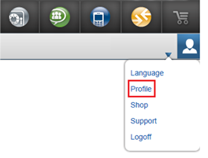
From the profile section, click on SETTINGS on the left, then select DOCUSIGN and enter your DocuSign login information. Click SAVE at the top when done to save the changes.

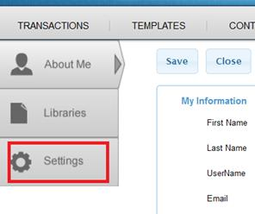

Once you have set this up, when you have a form opened within zipForm Plus there will be a pen icon on the toolbar that will allow you to use the e-sign integration within the program. See the image below for an example:

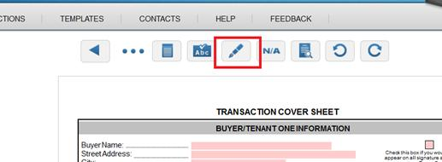

If you do not initially see this pen icon, click the three dots to the left side of the toolbar which will scroll over and show you more available icons to choose from:

